|  |
| --- |
|  |



**REPUBLIC OF TURKEY**

**ADANA ALPARSLAN TÜRKEŞ SCIENCE AND TECHNOLOGY UNIVERSITY**

**FACULTY OF ENGINEERING**

**DEPARTMENT OF COMPUTER ENGINEERING**

**WEATHER SERVICE**

**OSMAN INCI**

**BACHELOR DEGREE**

**SUPERVISOR**

**YASIN KAYA**

**2020-2021**

**ABSTRACT**

**WHEATER SERVICE**

Osman INCI

Department of Computer Engineering

Supervisor: Dr.Öğr. Yasin KAYA

1 2021, 12 pages

In this project we have downloaded Temperature, humudity, pressure,wind data from <https://mgm.gov.tr/> . we have learned how to grab javascript part of data from the web page. To do this we have used Selenium Headless browser. After grab this data we have put it to database. We have made a simple Windows service program to do this job each 5 minutes. We have learned to grrab data from database and display it on an program that we have made using C# form application.

**Keywords:** Windows Service,C#,Selenium Headless,Wheather

**Contents:**

INTRODUCTION**………………………4**

IMPLEMENTATION**…………………..4**

*Selenium Headless browser………..4*

*Save to database…………..5*

*Windows Service:…………8*

*Windows Form (Interface):……10*

Weakness…………………………..11

CONCLUSION**………………………………11**

REFERENCES**……………………………..12**

1. **INTRODUCTION**

In this project we have downloaded Temperature, humudity, pressure,wind data from <https://mgm.gov.tr/> . we have learned how to grab javascript part of data from the web page. To do this we have used Selenium Headless browser. After grab this data we have put it to database. We have made a simple Windows service program to do this job each 5 minutes. We have learned to grrab data from database and display it on an program that we have made using C# form application.

**IMPLEMENTATION**

***Selenium Headless browser:***

To use selenium headless browser we need to download Selenium package to our project. Also we have download chromedriver.exe file to debug folder of our project.now we are ready to start.

IWebDriver driver = new ChromeDriver(options);

We have created driver. With options we choose to use as headless.

Getdata(url, myreader.GetString(0), myreader.GetString(1), MysqlconectionsString,driver);

We have created a function that gets url,Province ,disctrit ,mysqlconnectionstring and the selenim broweser as arguments. Right now lets just focus on Selenium part and do not care about Database that we will already cover later. Basically,we have url of webpage and driver.

driver.Navigate().GoToUrl(url);//connect to the url

we have connected to url by code above.

string path = "C:/MgmService/downloaded/";

we need to download some images from web page. That is where we are goning to save

var temperature = driver.FindElement(By.XPath("//*[@id=\"pages\"]/div/section/div[5]/div[1]/div[1]"));

above line of code we got Xpath of temperature and assigned this value to temperature. Using this method we have downloaded all necessary data from the web page. But when we have downloaded image we need to use Webclient to download this image to the path we have defined above. Name of the image or icon is *[name of city + name of district+name of image]* for example lets say we are downloading icon of Weather which sun,cloud or wind. And we need to download this For “Ankara” “keçiren” then name of this file will be “AnkaraKeçiörenTypeImg.svg”. now we are done with Selenium part of the project.

**Save to database:**

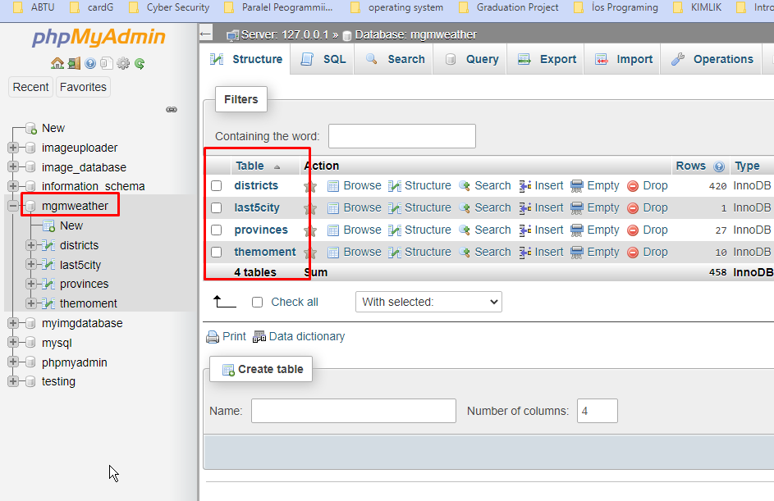we have used xampp as server. We have created Database as mgmweather.

And we have 4 tables as shown above.

**Districts:** contains name of all disctrict with province

**Last5city**:contains last 15 search user have made on the program. If user makes more than 15 searched then this table will be cleaned and will start to write from the begining.The reason we have this database table is that we dont want to download all the cities which will be alot of data and useless because maybe the user will never look for some cities. But we will keep download to slow the connection down. Each time user make serarch on the application it is saved in here.

**Provinces:** have names of the cities we have done search for. This table is never deleted.each time user make search for new city it will be added to here and from here we will add to **districts** that save city name with province name so we can get data from districts to use in combobox on windows form application.

**Themoment:** it max can have 15 elements that are data for the searches in Last5city.

After we have done some introduction to our database lets see on the code:

string query = "SELECT `Province` ,`district` FROM `last5city`";

we get all searches that user have made.

string MysqlconectionsString = "datasource=127.0.0.1;port=3306;username=root;password=;database=mgmweather";

we have set our mysqlconnection string.

MySqlCommand commandDatabase = new MySqlCommand(query, databaseconnection);

Command is set with the query.we want to get data from **last5city** table

while (myreader.Read())

will we get all the data we keep go forward

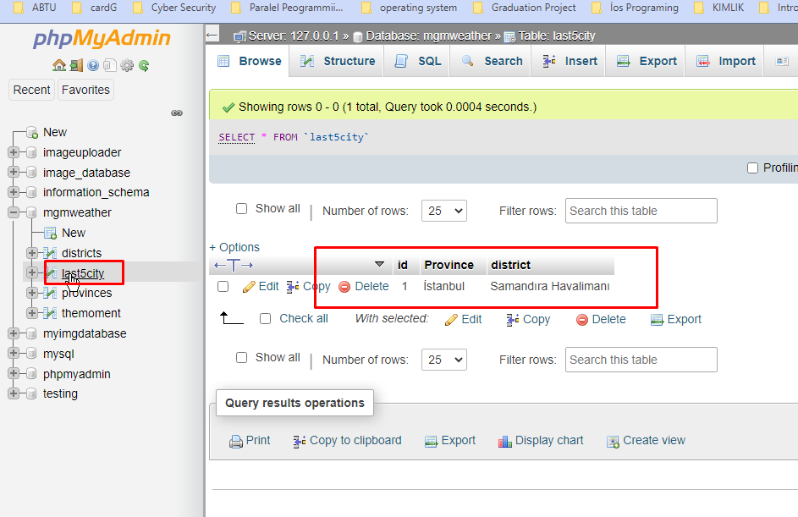

myreader.GetString(0), myreader.GetString(1)

as we can see we have id , province and district name.but in out query we simply get province and districy that is why getstring(0) is province and getstring(1) is name of district that user have made search for.

Getdata(url, myreader.GetString(0), myreader.GetString(1), MysqlconectionsString,driver);

As we have mentioned before we are sending these values to our function.

string queryProv = "SELECT `Name` FROM `provinces`";

in our Getdata function we want to get name of the cities that we saved to our Provinces table.

int checkflag = 1;

prvns=driver.FindElement(By.Id("cmbIl")).GetAttribute("value");

prvns is suppose to be name of the city that was sent to Getdata function. After we have this city and distrct name with url we have done search on and we get name of this city from web. Because we want to make sure that name of city is written correctly.

If name of city is writen wrongly then mgm.gov.tr will give us “Ankara” “keçiören” by default.so this prvns is name of province user looks for.

As we have mentioned above we want to get all provinces in our Province table we compare with prvns. If it exist we will write results to “themoment “ table. If this city doesnot exist in our provinces than it means also we dont its districts. that is why we need to get all district names and put them to districts table as we have done below

var distrs = driver.FindElement(By.Id("cmbIlce"));///we gets distrct

queryProv = "INSERT INTO `districts`(`id`, `Nam`, `ProvName`) VALUES (NULL,'" + cleands + "','" + prvns + "')";

**Windows Service:**

We have used Toshalf to build our Windows service

public class MgmData

we have a class that our service will run.

_timer = new Timer(300000) { AutoReset=true};

We have set each 5 minutes run.

_timer.Elapsed += TimerOver;

When given time is over it will run TimerOver that start our driver to start to grab data from web.all those are happeining in a class that we have created that is why we need to call this class. We do this in main part. We have used topshalf for this.

s.ConstructUsing(mgmservice => new MgmData());

 s.WhenStarted(mgmservice => mgmservice.Start());

 s.WhenStopped(mgmservice => mgmservice.Stop());

as shown above we have called our service to run.

x.SetServiceName("MgmHavaDurumu");

x.SetDisplayName("Mgm Hava Durumu");

x.SetDescription("Bu servis Mgm http://mgm.gov.tr sitesinden 5 dk bir anlık hava durmunu Getirmektedir");

in above we have set name and Description for our Srervice.when we run and services and look for MgmHavaDurumu we will see our service is running if we have run it.

We have copied deubg folder into MgmService.

Then we started our service using cmd command prompt. We need to run

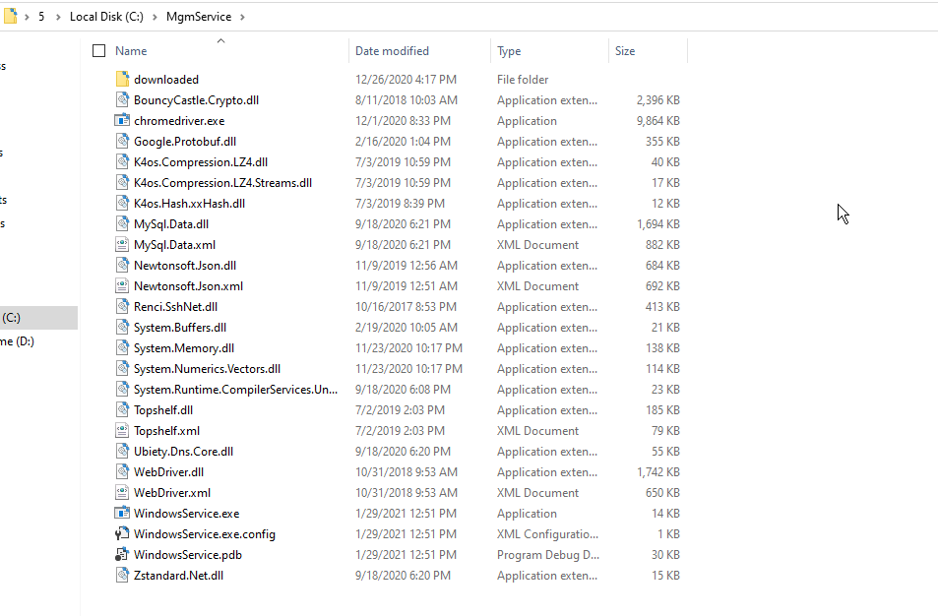as administrator and run it.

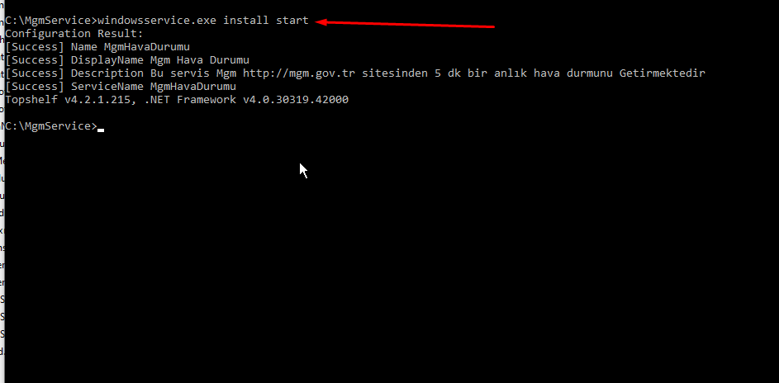

then we need to check on the task manager services.

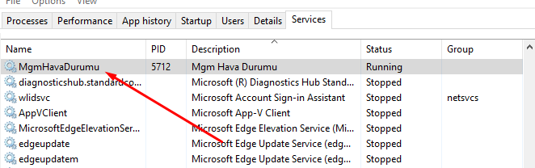Windows Form (Interface):

In this part we simply focus on getting data from “themoment” table in Database . And insert new searched to Last5city table. Also we get data from “discricts” and “provinces” table to display on our combobox. Additional to all of these also we provide a user to type name of city with simple textbox. The reason we do that is our database is not containing all the cities. So when user type name of city we simply check on the web site if there is a city with this name we then add this city to our table to display on here.

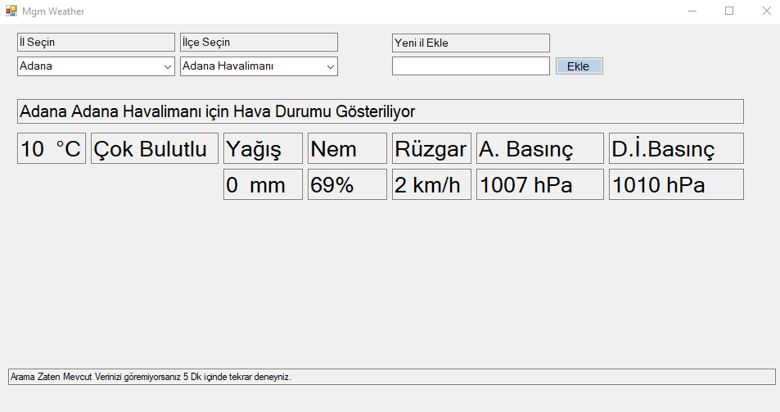

Weakness

our program suppose to get data of a city instantly. But when user look for the city that they have never been looked or no in last 15 search then Our program will not display the weather. We assume that whoever uses this application looks for a specific city.

The other weakness of the program is that when we get Images or icons from the web for some of the cities we are not able to get icons. But still if the icon is not downloaded we are able to run the program by simple try catch method. This weakness is also about icons. For example icon of wind is always displayed to down. But actually acording to wind speed it must change. We have done some work one Bitmap image to rotate the image. But we were not able to do that totally. That part is left in comments in case we find more time to solve.

**CONCLUSION**

We have learned how to grab data from a web page not html data but also javascript part of the data. We have learned how to preapre a windows service program and run it on our system.Also we have used xampp to upload file to our database. And grab from database.

**REFERENCES**

<https://www.c-sharpcorner.com/article/creating-windows-service-in-net-with-topshelf/>

<https://www.youtube.com/watch?v=y64L-3HKuP0&list=PL2Iztoz1Gjjh9lJoV14lQ9NcDQp5NhujI>